**Test Case** **0031**

**System:** VirtuCardsClient & VirtuCardsHost

**Description:** Tests that the host can kick a player from the game if necessary

**Severity:** 3

**Instructions**

**Test 1**

1. Start VirtuCardClient application
2. Click the button labeled “Sign In”
3. Enter “virtucards01@gmail.com” into the text input labeled “Enter email…”
4. Enter “Testing1” into the text input labeled “Enter password…”
5. Press the button labeled “Login”
6. A window should appear saying “Login Success”
7. Press the OK button that appears on that window
8. Start VirtuCardHost application
9. Repeat steps 2-7 but on the VirtuCardHost application
10. The checkbox “Allow Host to Join” should be checked on the host
11. On the dropdown select test game as the gamemode
12. Press the Create Game Button
13. In the VirtuCardClient application enter the 6-character room code found on the host’s screen into the field labeled “Enter Code…”
14. The client should be taken to the waiting screen and the username “Testing0001” should appear on the host
15. Press the Start Game button on the host
16. On the host screen click the “kick player” button



* This is what the button looks like for reference

**Expected Result:** A panel with a dropdown including all the players in the game should appear for the host to choose from.

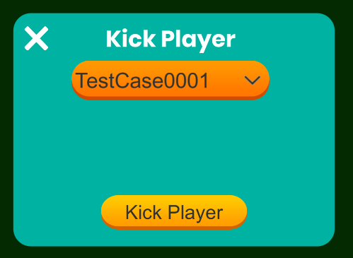

* Here is what the panel should look like

1. Once the panel is open, click the “Kick Player” button.

**Expected Result:** On the host the game will end since there are no more players and on the client they will be back on the join game page with an error saying they have been kicked.

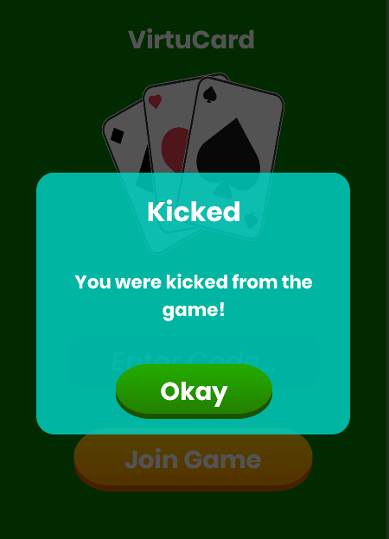

* This is what should be displayed on the client side

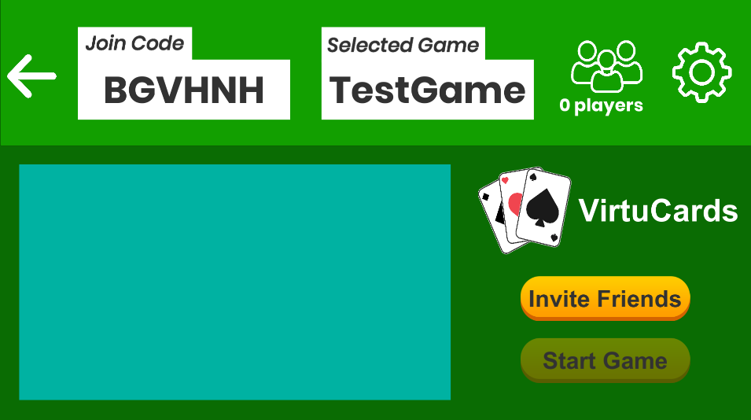

* Since that player was the only one in the game, the host will automatically end the game since there is no longer the minimum number of required players in the game.

**Test 2**

1. Start VirtuCardClient application
2. Click the button labeled “Sign In”
3. Enter “virtucards01@gmail.com” into the text input labeled “Enter email…”
4. Enter “Testing1” into the text input labeled “Enter password…”
5. Press the button labeled “Login”
6. A window should appear saying “Login Success”
7. Press the OK button that appears on that window
8. Start a second VirtuCardClient and login using the anonymous account button
9. Start VirtuCardHost application
10. Repeat steps 2-7 but on the VirtuCardHost application
11. The checkbox “Allow Host to Join” should be checked on the host
12. On the dropdown select test game as the gamemode
13. Press the Create Game Button
14. In both VirtuCardClient applications enter the 6-character room code found on the host’s screen into the field labeled “Enter Code…”
15. The clients should be taken to the waiting screen and the username “Testing0001” and “Anonymous####” should appear on the host
16. Press the Start Game button on the host
17. On the host screen click the “kick player” button



* This is what the button looks like for reference

1. Once the panel is open select the anonymous player from the dropdown
2. Click the “Kick Player” button

**Expected Result:** On the host side there will be a panel displayed showing which player has just been kicked from the game. On the client that has been kicked, there should be an error message showing they have been kicked from the game and they should be back on the join game page. The other client should remain in the game.



* This is what the kicked client should see on their screen once they have been kicked.

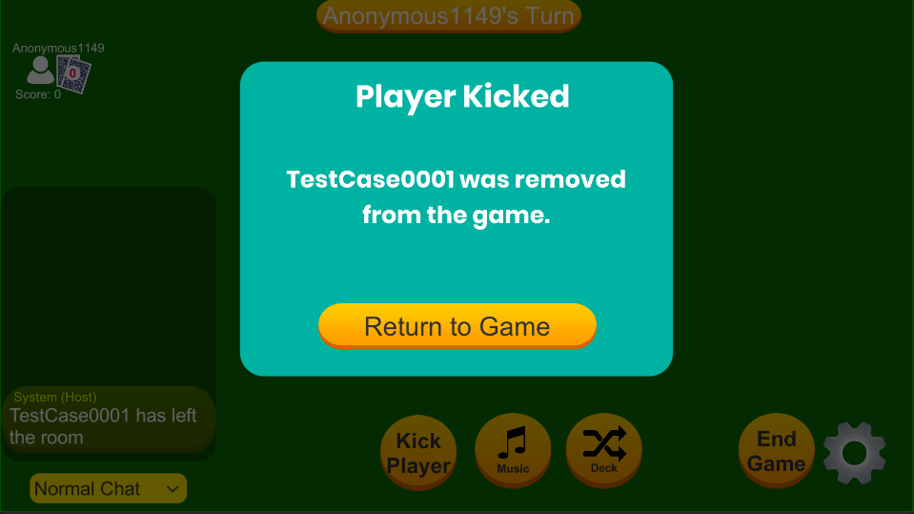

* This is what the host should have displayed on their screen after a player has been kicked from the game

**Test 3**

1. Start VirtuCardClient application
2. Click the button labeled “Sign In”
3. Enter “virtucards01@gmail.com” into the text input labeled “Enter email…”
4. Enter “Testing1” into the text input labeled “Enter password…”
5. Press the button labeled “Login”
6. A window should appear saying “Login Success”
7. Press the OK button that appears on that window
8. Start a second VirtuCardClient
9. Login using the anonymous account button
10. Start VirtuCardHost application
11. Repeat steps 2-7 but on the VirtuCardHost application
12. The checkbox “Allow Host to Join” should be checked on the host
13. On the dropdown select War as the gamemode
14. Press the Create Game Button
15. In both VirtuCardClient applications enter the 6-character room code found on the host’s screen into the field labeled “Enter Code…”
16. The clients should be taken to the waiting screen and the username “Testing0001” and “Anonymous####” should appear on the host
17. Press the Start Game button on the host

**Expected Result:** Since we have chose war for the game mode this time around, the UI should be updated accordingly.

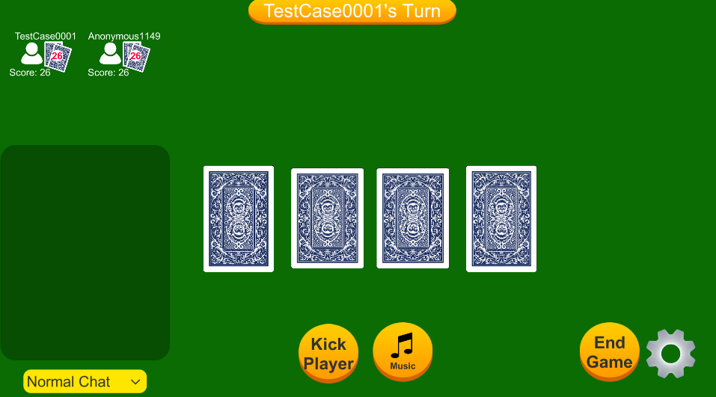

* Here is what the Host UI should look like once the game has been started if War has been selected

1. On the host screen click the “kick player” button



* This is what the button looks like for reference

1. Once the panel is open select the anonymous player from the dropdown
2. Click the “Kick Player” button

**Expected Result:** On the host side there will be a panel displayed showing which player has just been kicked from the game. On the client that has been kicked, there should be an error message showing they have been kicked from the game and they should be back on the join game page. The other client should remain in the game.



* This is what the kicked client should see on their screen once they have been kicked.

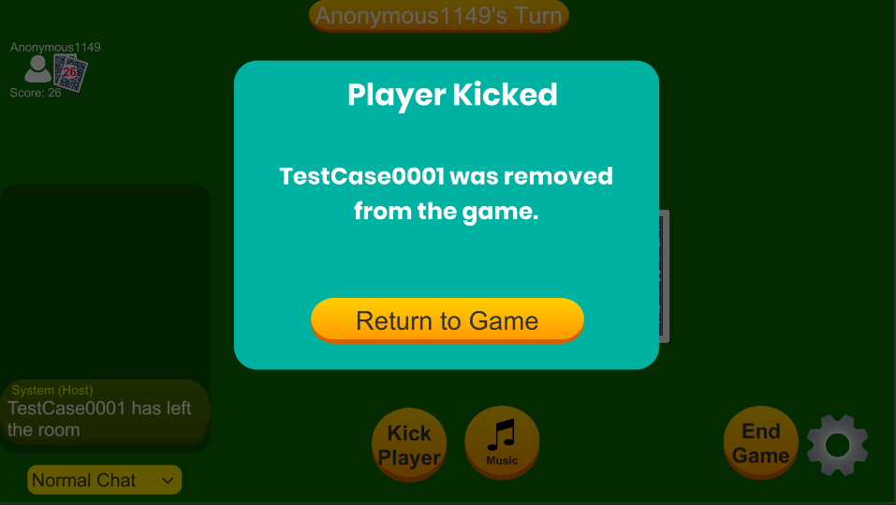

* This is what should be displayed on the host side when a player has been kicked from the game in War. The other client should remain in the game.

**Test 4**

1. Start VirtuCardClient application
2. Click the play anonymously button
3. Start a second VirtuCardClient application
4. Click the play anonymously button
5. Start VirtuCardHost application
6. Repeat steps 2-7 but on the VirtuCardHost application
7. The checkbox “Allow Host to Join” should be checked on the host
8. On the dropdown select test game as the gamemode
9. Press the Create Game Button
10. In both VirtuCardClient applications enter the 6-character room code found on the host’s screen into the field labeled “Enter Code…”
11. The clients should be taken to the waiting screen and the username “Anonymous####” and “Anonymous####” should appear on the host
12. Press the Start Game button on the host
13. On the host screen click the “kick player” button



* This is what the kick player button should look like

**Expected Result:** A panel with a dropdown including all the players in the game should appear for the host to choose from.

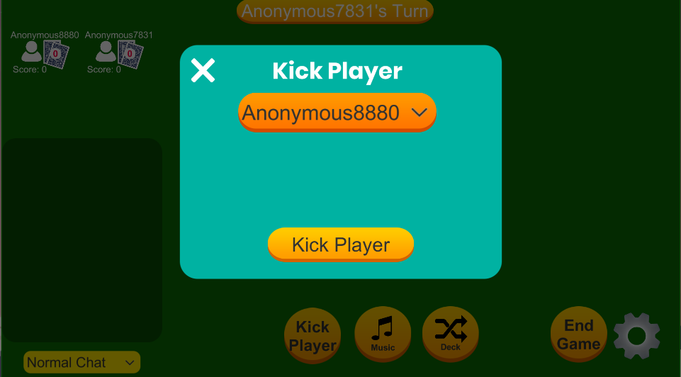

* This is what should be shown on the host side

1. Click the “Kick Player Button”

**Expected Result:** On the host, a panel showing which of the two players was kicked. On the client that was kicked they should be removed and shown a message telling them they have been kicked. The other client should remain in the game.

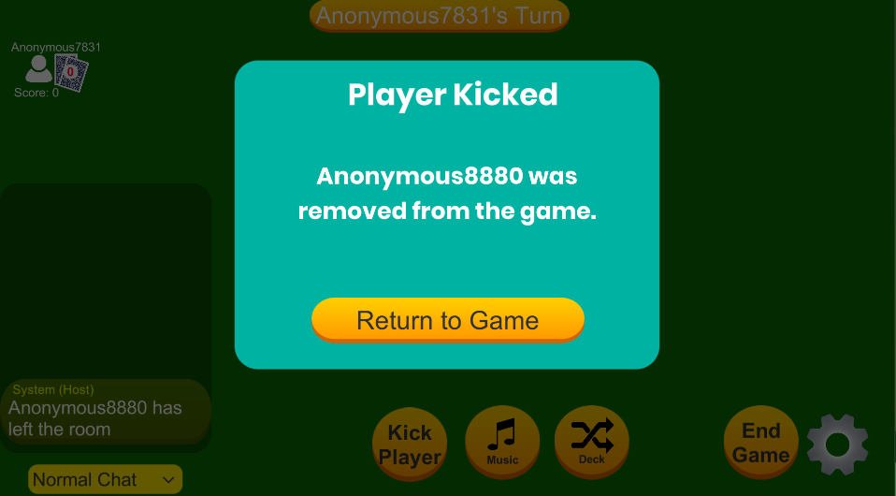

* This is what should be shown on the host side



* This is what should be shown on the player who was kicked from the game